Machine learning:
Python Practice Questions in class:
Date: 11 may 2025

Q. Display a message “Done!” after successful execution of loop.
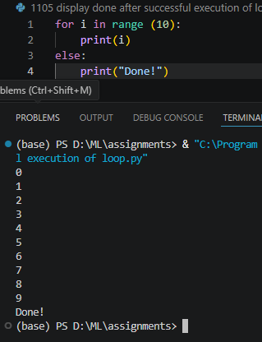
Q. Calculate the sum of all natural numbers from 1 to N.
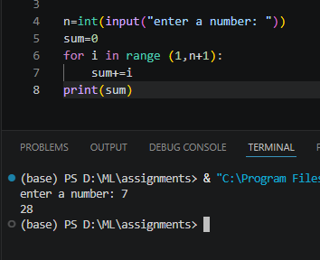
Q. Print multiplication table of a given number. (Given input= 2)
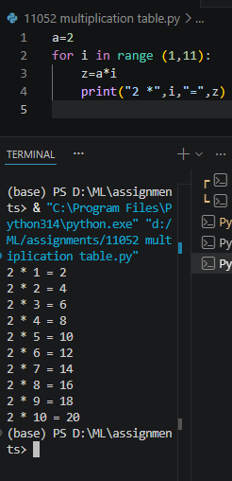
Q. Calculate cube the cube of the all numbers from 1 to a given number 3.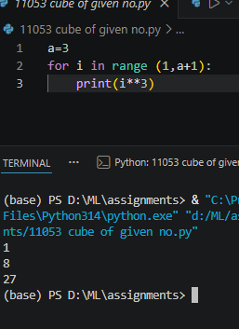
Q. Print list in reverse order.
List=[10,20,30,40,50]
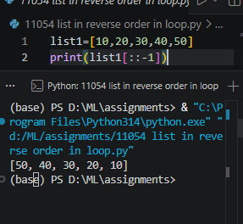

Q. Count Vowels and consents in a sentence.
Given Sentence: “loops are fun!”
